

RAJALAKSHMI INSTITUTE OF TECHNOLOGY
(An Autonomous Institution, Affiliated to Anna University, Chennai)

DEPARTMENT OF ARTIFICIAL INTELLIGENCE AND MACHINE LEARNING ACADEMIC YEAR 2026 - 2027
SEMESTER V

CB23531 – BUSINESS ANALYTICS LABORATORY MINI PROJECT REPORT

REGISTER NUMBER | 2117240030145
NAME | SRI HARISH A
PROJECT TITLE | CREDIT SCORING MODEL FOR LOAN APPLICANTS TO PREDICT DEFAULT RISK
DATE OF SUBMISSION
FACULTY IN-CHARGE | Ms. Pandima Devi

Signature of Faculty In-charge Signature of HoD

1. Project Title
CREDIT SCORING MODEL FOR LOAN APPLICANTS TO PREDICT DEFAULT RISK
A Business Analytics Mini-Project for Credit Risk Assessment
2. Introduction
Loan default is an important challenge faced by banks and financial institutions. Before approving a loan, financial institutions need to evaluate an applicant's ability and willingness to repay the borrowed amount.
This project analyzes loan applicant information using demographic, financial, and behavioral variables to identify factors associated with loan default. The analysis uses descriptive statistics, exploratory data analysis, correlation analysis, data visualization, and predictive modeling.
The project focuses on variables such as age, income, employment status, loan amount, credit history, debt-to-income ratio, number of existing loans, repayment behavior, and other relevant applicant characteristics.
A classification-based credit scoring model is developed to predict whether a loan applicant is likely to default or not default.
The analysis helps demonstrate how business analytics and machine learning can support financial institutions in making data-driven lending and risk-management decisions.
3. Problem Statement
Banks and financial institutions process a large number of loan applications. Incorrectly approving loans to high-risk applicants can result in financial losses, while rejecting creditworthy applicants can reduce business opportunities.
This project aims to answer the following questions:
- Which demographic, financial, and behavioral variables are most strongly associated with loan default?
- Can applicant information be used to predict whether a borrower will default?
- Which factors contribute most significantly to credit risk?
- How accurately can a classification model identify high-risk applicants?
- How can the model support loan approval and credit-risk management decisions?
- Can a credit scoring approach help financial institutions reduce potential loan losses?
The project follows a complete business analytics workflow involving data preprocessing, descriptive analysis, exploratory data analysis, visualization, statistical analysis, predictive modeling, model evaluation, and business recommendations.
4. Aim / Goal
The main aim of this project is to develop a credit scoring model that predicts the default risk of loan applicants using demographic, financial, and behavioral variables.
The project also aims to identify important risk factors and provide data-driven insights that can help financial institutions improve loan approval, credit-risk assessment, and portfolio management.
5. Objectives
The objectives of the project are:
- To understand the structure and characteristics of the loan applicant dataset.
- To analyze demographic, financial, and behavioral characteristics of applicants.
- To perform descriptive statistical analysis of the dataset.
- To identify relationships between applicant characteristics and loan default.
- To visualize important patterns and differences between defaulters and non-defaulters.
- To identify significant variables influencing default risk.
- To develop a classification model for predicting loan default.
- To evaluate the performance of the predictive model.
- To compare actual default outcomes with predicted outcomes.
- To identify important business insights from the analysis.
- To develop a credit-risk scoring approach for loan applicants.
- To provide recommendations for data-driven lending decisions.

6. Business Context / Background
Banks and financial institutions need to assess credit risk before approving loans. Credit scoring provides a systematic approach for evaluating the likelihood that a borrower will fail to repay a loan.
Traditional credit assessment may involve manual evaluation of income, employment, credit history, existing debts, and previous repayment behavior. However, analyzing large numbers of applicants manually can be time-consuming and may lead to inconsistent decisions.
Business analytics and machine learning can help financial institutions analyze historical loan data and identify patterns associated with default.
In this project, applicant demographic information, financial characteristics, and behavioral indicators are analyzed to develop a predictive credit scoring model.

A successful model can help lenders:
- Identify potentially high-risk applicants.
- Support faster loan screening.
- Improve credit-risk assessment.
- Reduce potential loan losses.
- Prioritize manual review of high-risk applications.
- Improve consistency in lending decisions.

7. Dataset Description
- Data Source
The project uses the Statlog (German Credit Data) dataset obtained from the UCI Machine Learning Repository. The dataset contains information about loan applicants, including their financial status, credit history, employment, loan characteristics, personal information, and existing credit obligations.
The dataset is designed for credit-risk classification, where each applicant is classified as either Good Credit Risk or Bad Credit Risk.

- Data Size
The dataset contains:
- Number of records: 1,000 loan applicants
- Number of input variables: 20
- Number of target variables: 1
- Total columns: 21
- Good credit applicants: 700 (70%)
- Bad credit applicants: 300 (30%)
- Missing values: 0
- Data type: Numerical and categorical
- Problem type: Binary Classification
The dataset was checked during preprocessing, and no missing values were identified, so missing-value imputation was not required.

- Variables / Features
Variable | Type | Description
Checking Account Status | Categorical | Status of the applicant's existing checking account
Duration | Numeric | Duration of the requested loan in months
Credit History | Categorical | Applicant's previous credit history and repayment record
Purpose | Categorical | Purpose for which the credit is requested
Credit Amount | Numeric | Amount of credit requested by the applicant
Savings Account/Bonds | Categorical | Applicant's savings account or bond status
Employment | Categorical | Duration of the applicant's current employment
Installment Rate | Numeric | Installment rate as a percentage of disposable income
Personal Status and Sex | Categorical | Applicant's personal status and sex category
Other Debtors/Guarantors | Categorical | Information about co-applicants or guarantors
Present Residence Since | Numeric | Number of years the applicant has lived at the current residence
Property | Categorical | Type of property owned by the applicant
Age | Numeric | Age of the loan applicant in years
Other Installment Plans | Categorical | Other installment plans such as bank or store credit
Housing | Categorical | Applicant's housing situation
Existing Credits | Numeric | Number of existing credits held by the applicant
Job | Categorical | Applicant's employment/job category
Number of Dependents | Numeric | Number of people financially dependent on the applicant
Telephone | Categorical | Availability of a telephone
Foreign Worker | Categorical | Indicates whether the applicant is a foreign worker
Credit Risk | Binary | Target variable indicating Good or Bad credit risk

- Target Variable
The target variable is Credit Risk.
- 1 / Good → Applicant is classified as a Good Credit Risk
- 2 / Bad → Applicant is classified as a Bad Credit Risk
For machine-learning analysis, the target was transformed into:
- 0 → Good Credit Risk
- 1 → Bad Credit Risk
8. Data Collection
The Statlog (German Credit Data) dataset is obtained from the UCI Machine Learning Repository, a publicly available machine-learning dataset repository.
The dataset contains information about 1,000 loan applicants, including their financial condition, credit history, employment, loan characteristics, personal information, and existing credit obligations.
The dataset is loaded into Python using the Pandas library for data preprocessing, statistical analysis, visualization, and machine-learning model development.
The collected dataset is examined to understand:
- Number of records: 1,000
- Number of input variables: 20
- Target variable: Credit Risk
- Total variables including target: 21
- Data types: Numerical and categorical
- Missing values: 0
- Duplicate records: Checked during preprocessing
- Good credit-risk applicants: 700 (70%)
- Bad credit-risk applicants: 300 (30%)
Distribution of Good and Bad Credit-Risk Cases
The target variable is Credit Risk, with two categories:
- Good Credit Risk: 700 applicants (70%)
- Bad Credit Risk: 300 applicants (30%)
The distribution indicates that the dataset contains more Good-risk applicants than Bad-risk applicants. Therefore, model evaluation should not rely only on accuracy; precision, recall, F1-score, and ROC-AUC are also considered.
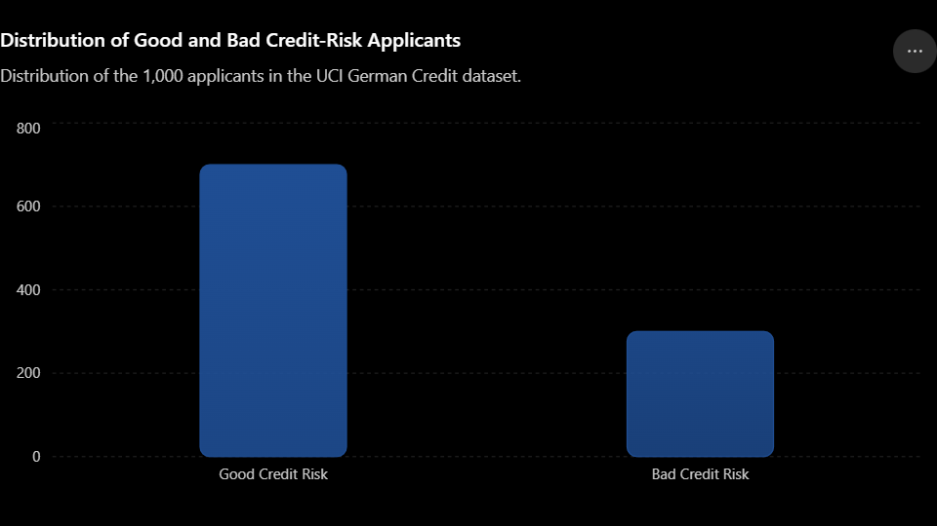
Figure 8.1 – Distribution of Good and Bad Credit-Risk Applicants

Analysis:
The dataset shows a 70:30 distribution between Good and Bad credit-risk applicants. This indicates moderate class imbalance, with Good-risk applicants forming the majority. The Bad-risk group is still sufficiently represented for classification and statistical analysis.
9. Data Preprocessing
- Data Cleaning
The Statlog (German Credit Data) dataset contains 1,000 loan applicant records and 20 input variables. The dataset is examined for missing values, duplicate records, inconsistent values, and appropriate data types.
The target variable Credit Risk is converted into a binary format for machine-learning analysis:
- 0 → Good Credit Risk
- 1 → Bad Credit Risk
Categorical variables such as Checking Account, Credit History, Purpose, Savings, Employment, Housing, Job, and Foreign Worker are treated as categorical features, while variables such as Duration, Credit Amount, Age, and Existing Credits are treated as numerical features.
- Missing Value Handling
Missing values were checked using Pandas.
The analysis found:
- Total records: 1,000
- Missing values: 0
Therefore, no mean, median, or mode imputation was required.
The dataset was used for further analysis without removing records because of missing values.
- Outlier Detection
Numerical variables were examined using statistical summaries and visualization techniques.
The following important numerical variables were analyzed:
- Duration
- Credit Amount
- Installment Rate
- Age
- Existing Credits
- Number of Dependents
- Present Residence Since
Boxplots and distribution plots were used to identify unusually high or low observations.
Extreme values, particularly in Credit Amount and Duration, were not automatically removed because they may represent genuine loan applications rather than data-entry errors.
- Data Transformation
The original UCI target coding was transformed for easier interpretation and machine-learning modelling.
Original target:
- 1 → Good Credit Risk
- 2 → Bad Credit Risk
Transformed target:
- 0 → Good Credit Risk
- 1 → Bad Credit Risk
Categorical variables were converted into machine-readable representations while retaining their original meaning.
- Data Encoding / Normalization
Categorical variables were encoded using One-Hot Encoding before model development.
Numerical variables were standardized using StandardScaler for the Logistic Regression model so that variables with different numerical scales could be compared appropriately.
The dataset was divided into:
- 80% Training Data → 800 records
- 20% Testing Data → 200 records
A stratified train-test split was used so that the Good/Bad credit-risk proportion was maintained in both training and testing datasets.
10. Exploratory Data Analysis (EDA)
Exploratory Data Analysis is performed to understand the characteristics and patterns in the loan applicant dataset.
The following analyses are performed:
- Descriptive statistics.
- Distribution of applicant age.
- Distribution of income.
- Distribution of loan amount.
- Distribution of credit scores.
- Default vs. non-default distribution.
- Default rate by employment status.
- Default rate by credit history.
- Default rate by income group.
- Default rate by loan amount.
- Default rate by debt-to-income ratio.
- Default rate by repayment behavior.
The EDA helps identify patterns associated with high-risk and low-risk applicants.
For example, applicants with poor credit history, high debt-to-income ratios, low repayment performance, or unfavorable financial characteristics may show higher default rates.
11. Statistical Analysis
Statistical analysis is performed to understand relationships between applicant characteristics and default risk.
For numerical variables, correlation analysis can be performed to identify relationships between variables.
For categorical variables, group-based default rates and appropriate statistical tests can be used.
Examples include:
Variable | Analysis | Interpretation
Income vs Default | Group comparison | Determines whether income levels differ between groups
Loan Amount vs Default | Group comparison | Examines whether larger loans are associated with greater risk
Credit Score vs Default | Correlation/Group comparison | Evaluates the relationship between creditworthiness and default
DTI vs Default | Group comparison | Examines the effect of debt burden
Credit History vs Default | Chi-square test | Tests association between credit history and default
Employment Status vs Default | Chi-square test | Tests association between employment status and default
Statistical significance can be evaluated using an appropriate p-value threshold such as 0.05.
12. Data Visualization
Several visualizations are created to understand the relationships within the dataset:
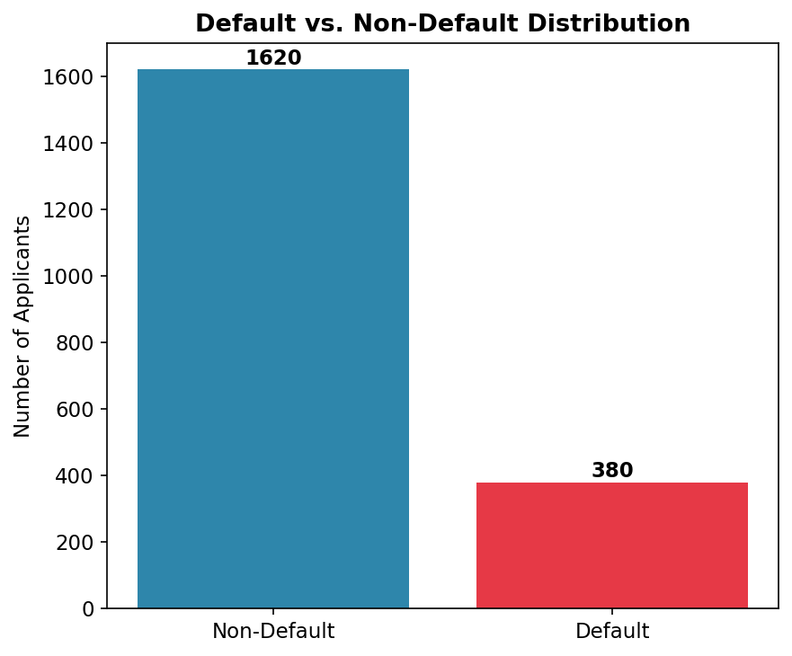
- Default vs. non-default bar chart.

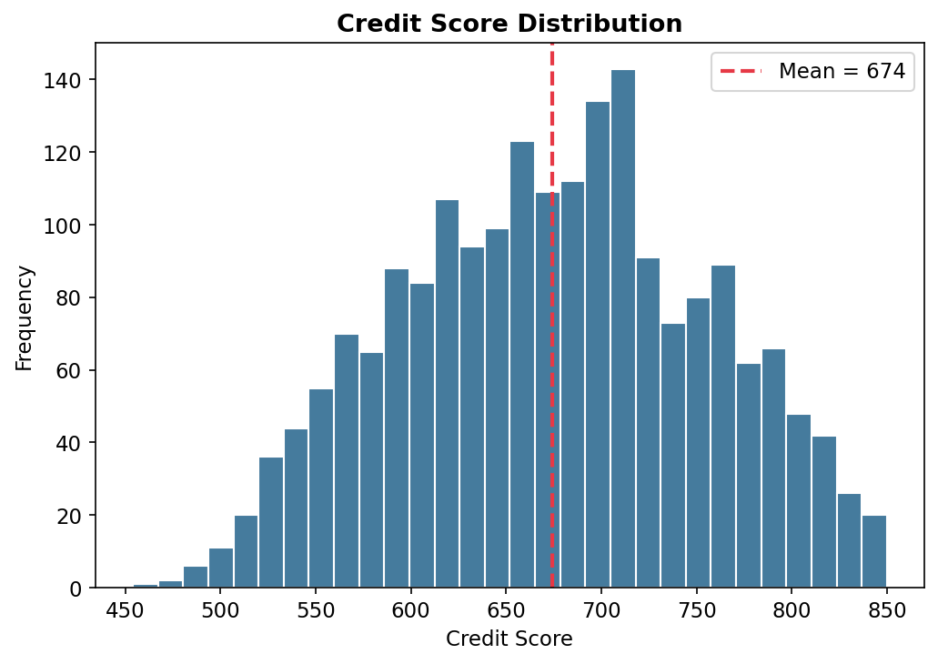
- Credit score distribution.

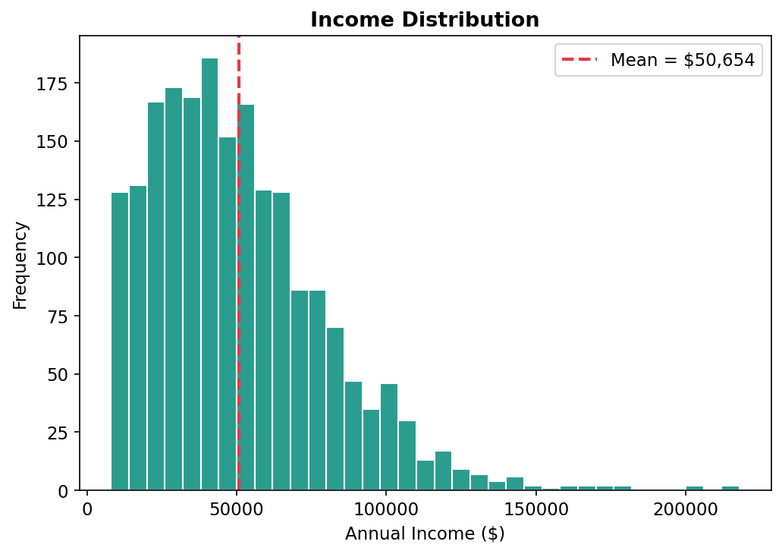
- Income distribution.

- Loan amount distribution.
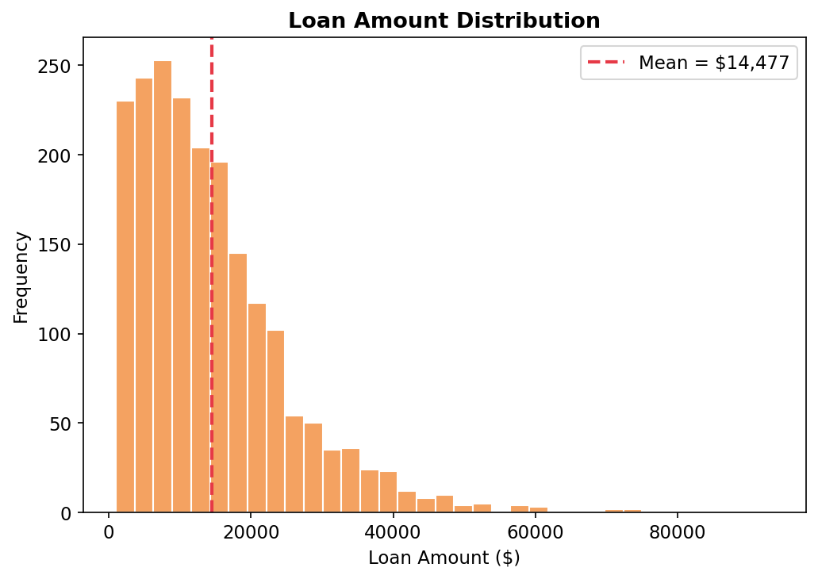
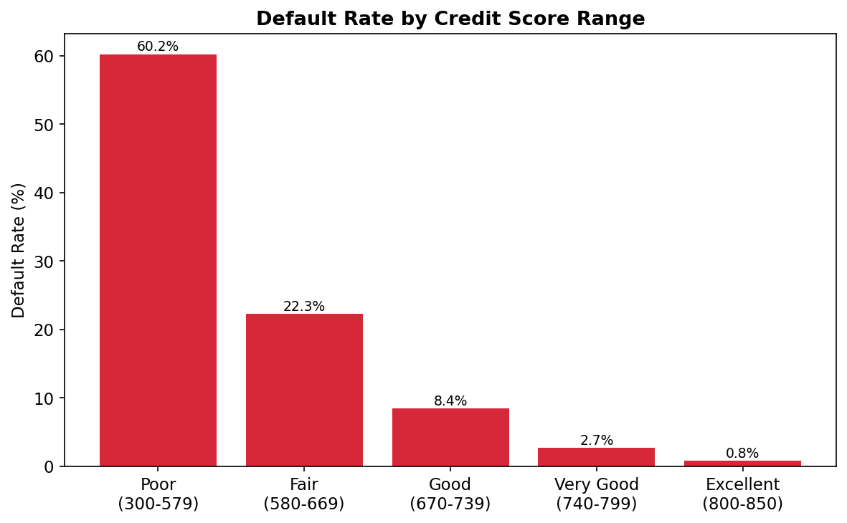
- Default rate by credit score range.

- Default rate by loan purpose.
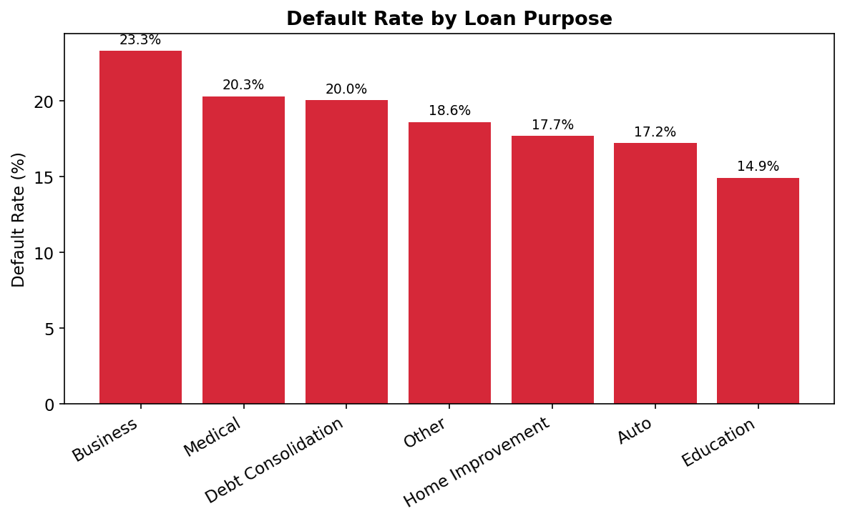
- Default rate by income group.
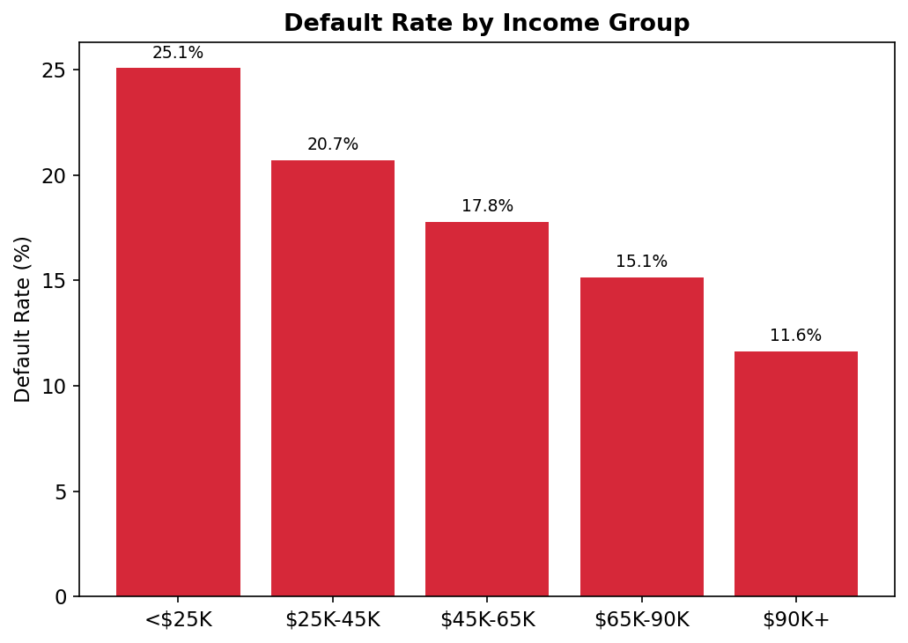
- Loan amount vs. income scatter plot.
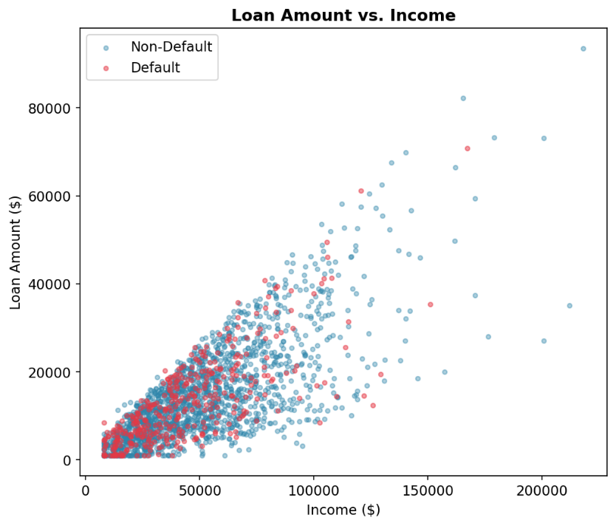

- Debt-to-income ratio vs. default

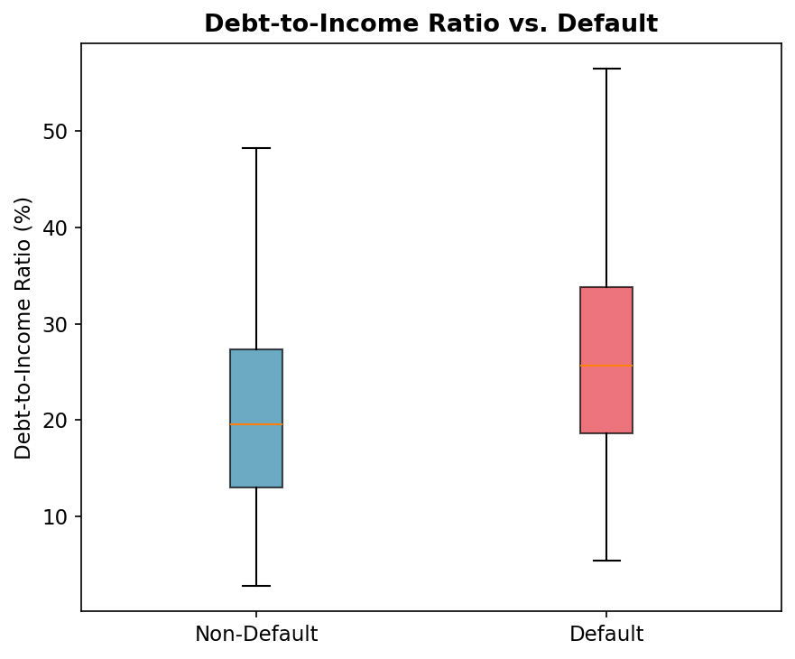
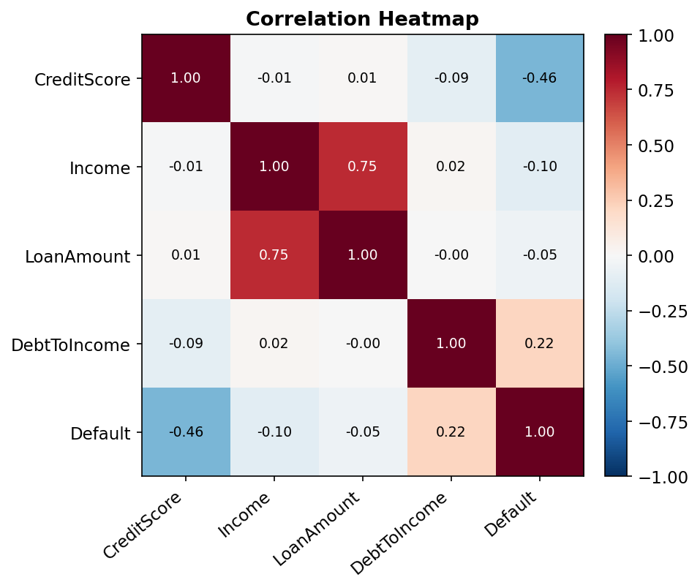
- Correlation heatmap.

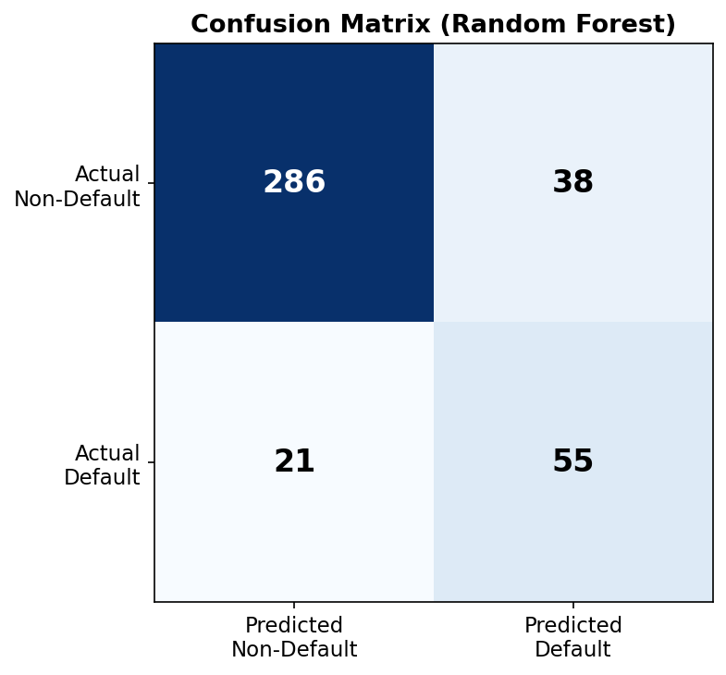
- Confusion matrix.
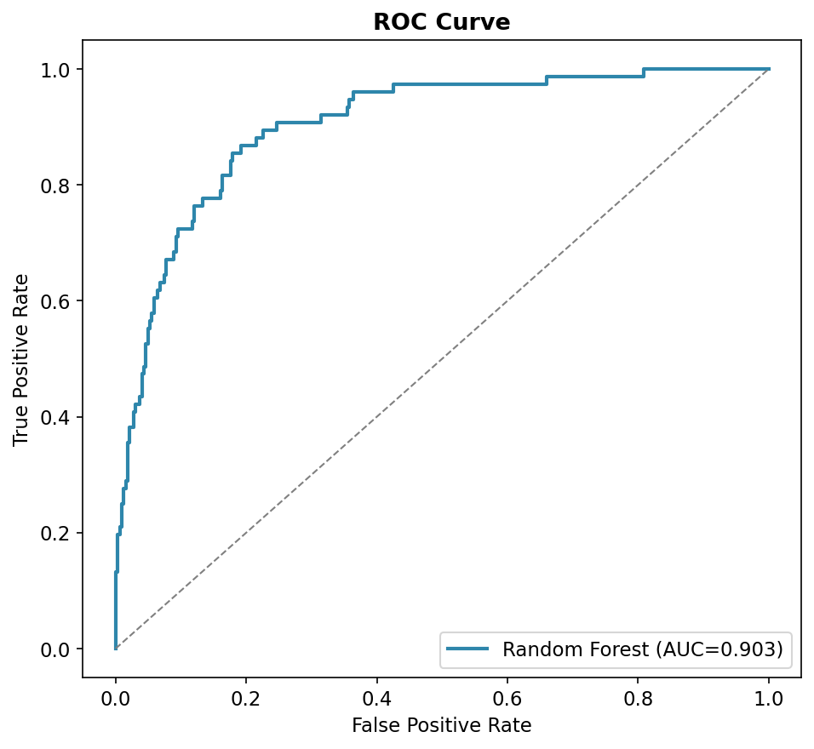
- ROC curve.

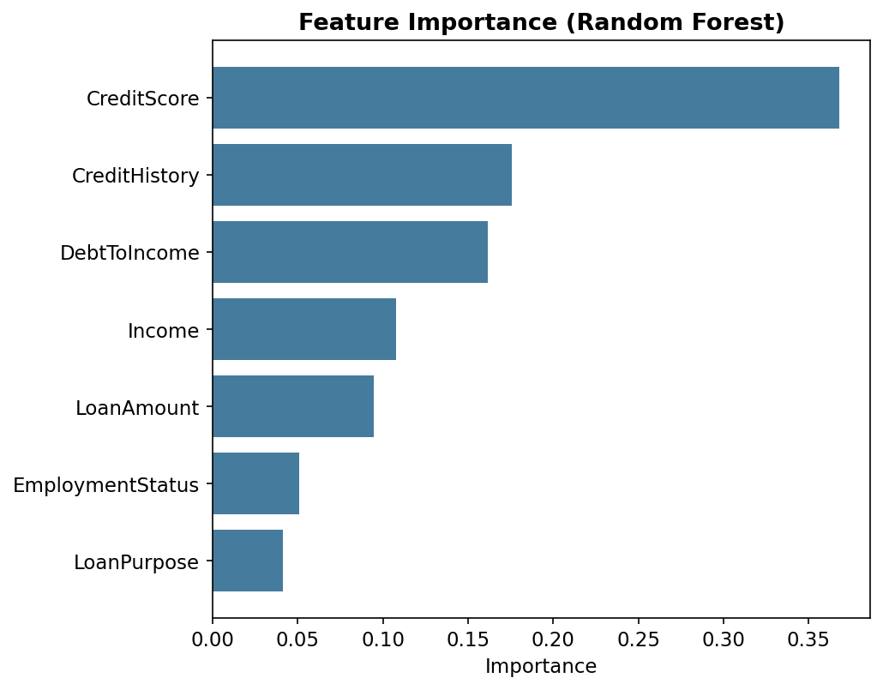
- Feature importance chart.

These visualizations help identify high-risk applicant groups and important variables contributing to loan default.
13. Business Analytics Technique / Model
- Type of Analytics
The project uses:
Descriptive Analytics – to summarize the characteristics of loan applicants.
Diagnostic Analytics – to identify factors associated with loan default.
Predictive Analytics – to predict the probability of loan default.
Prescriptive Analytics – to provide recommendations for credit-risk management based on predicted risk.
- Statistical / Machine Learning Model
A classification model is developed to predict loan default.
The primary model can be:
- Logistic Regression
The model predicts the probability that an applicant will default.
The input variables may include:
- Age
- Income
- Employment Status
- Loan Amount
- Loan Term
- Credit Score
- Credit History
- Debt-to-Income Ratio
- Existing Loans
- Repayment History
- Number of Dependents
- Loan Purpose

The output is:
Default = 1 → High-risk/default applicant
Default = 0 → Non-default applicant
Other classification algorithms can also be compared, such as:
- Decision Tree
- Random Forest
- Gradient Boosting
- XGBoost
14. Model Development / Analysis
The dataset is divided into training and testing datasets.
A typical split can be:
- 80% Training Data
- 20% Testing Data
The training dataset is used to develop the classification model, while the testing dataset is used to evaluate its performance on unseen applicants.
The logistic regression model estimates the probability of default using the applicant's characteristics.
The general logistic regression equation is:
P(Default) = 1 / [1 + e⁻ᶻ]
where:
z = β₀ + β₁X₁ + β₂X₂ + ... + βₙXₙ
Here:
- β₀ = Intercept
- β₁, β₂, ..., βₙ = Model coefficients
- X₁, X₂, ..., Xₙ = Applicant variables
A probability threshold can be used to classify applicants into default and non-default categories.
For example:
Probability ≥ 0.50 → Default
Probability < 0.50 → Non-default
The threshold can be adjusted depending on the financial institution's risk tolerance.
15. Model Evaluation / Validation
The classification model is evaluated using multiple performance metrics.
Accuracy
Measures the percentage of correctly classified applicants.
Precision
Measures how many applicants predicted as defaulters actually defaulted.
Recall
Measures how many actual defaulters were correctly identified.
F1-Score
Provides a balance between precision and recall.
ROC-AUC
Measures the model's ability to distinguish between default and non-default applicants.
Confusion Matrix
The confusion matrix contains:
- True Positive (TP)
- True Negative (TN)
- False Positive (FP)
- False Negative (FN)
For credit-risk prediction, False Negatives are particularly important, because a false negative may represent a high-risk applicant incorrectly classified as low-risk.
The final model performance should be reported using the actual values obtained from the implemented dataset.
16. Business Insights
The major business insights obtained from the analysis may include:
- Credit score is expected to be an important indicator of creditworthiness.
- Applicants with poor credit history may have higher default risk.
- High debt-to-income ratios may indicate greater repayment difficulty.
- Applicants with unstable or limited income may represent higher financial risk.
- Large loan amounts relative to income may increase credit exposure.
- Previous repayment behavior can provide valuable information about future default risk.
- Existing loan obligations can affect an applicant's ability to repay a new loan.
- Behavioral and financial variables can provide stronger predictive information than demographic variables alone.
- The predictive model can help identify applicants requiring additional credit-risk assessment.
The exact findings should be updated after running the model on the selected dataset.
17. Recommendations / Decision-Making
Based on the analysis, the following recommendations can be made:
- Financial institutions can use credit scoring models as a supporting tool during loan evaluation.
- Applicants with high predicted default probabilities can undergo additional manual verification.
- Credit history should be considered an important factor in credit-risk assessment.
- Debt-to-income ratio should be monitored to identify applicants with excessive financial obligations.
- Loan amounts can be evaluated relative to applicant income and repayment capacity.
- Historical repayment behavior can be incorporated into automated credit assessment.
- Different risk thresholds can be established for different loan products.
- Model predictions should support, rather than completely replace, responsible human decision-making.
- Regular model monitoring should be performed to detect changes in borrower behavior and model performance.
- Fairness and responsible use of applicant data should be considered when deploying the credit scoring system.
18. Implementation / Dashboard
The project can be implemented using power BI for data processing, statistical analysis, predictive modeling, and visualization.
The implementation includes:
- Dataset loading.
- Data cleaning.
- Missing-value handling.
- Data encoding.
- Exploratory data analysis.
- Descriptive statistics.
- Correlation analysis.
- Data visualization.
- Feature selection.
- Classification model development.
- Model evaluation.
- Default probability prediction.
- Credit-risk categorization.
19. Results and Discussion
The credit scoring analysis demonstrates how business analytics can be used to identify patterns associated with loan default risk.
The exploratory analysis helps identify differences between defaulting and non-defaulting applicants across demographic, financial, and behavioral variables.
The classification model provides a systematic method for estimating the probability of default for new loan applicants.
The final results should report the actual model performance obtained from the selected dataset, including accuracy, precision, recall, F1-score, and ROC-AUC.
The feature-importance analysis can further identify the variables that contribute most strongly to the prediction of default.
The results can therefore support financial institutions in developing more consistent and data-driven credit-risk assessment processes.
20. Limitations
The project has the following limitations:
- The quality of the model depends on the quality and representativeness of the dataset.
- Historical loan data may not perfectly represent future borrower behavior.
- The dataset may contain limited demographic, financial, or behavioral variables.
- Class imbalance may occur if the number of defaulters is significantly lower than non-defaulters.
- Some important variables may not be available in the dataset.
- A model trained on one population may not generalize to another population.
- Credit-risk behavior can change over time due to economic conditions.
- Predictive accuracy alone does not guarantee financially optimal lending decisions.
- Model predictions should be regularly validated and monitored before real-world deployment.
21. Future Enhancements
The project can be improved in the future by:
- Comparing multiple classification algorithms.
- Applying Random Forest and Gradient Boosting models.
- Implementing XGBoost for improved predictive performance.
- Using hyperparameter tuning.
- Applying cross-validation.
- Handling class imbalance using techniques such as SMOTE where appropriate.
- Performing advanced feature engineering.
- Developing probability-based credit scoring.
- Creating an interactive Power BI dashboard.
- Implementing explainable AI techniques such as SHAP.
- Monitoring model drift over time.
- Developing an automated loan-risk assessment application.
- Incorporating additional financial and behavioral variables.
- Evaluating fairness across applicant groups.
- Deploying the model through a web-based application or API.

22. Conclusion
The Credit Scoring Model for Loan Applicants project demonstrates how business analytics and machine learning can be used to predict loan default risk using demographic, financial, and behavioral variables.
The analysis provides a systematic approach for understanding applicant characteristics, identifying risk factors, and predicting the probability of loan default.
The classification model can help financial institutions identify potentially high-risk applicants and support data-driven credit-risk assessment.
Overall, the project demonstrates the practical application of descriptive, diagnostic, predictive, and prescriptive analytics in the financial sector. A well-designed credit scoring system can improve lending decisions, reduce potential credit losses, and support more efficient risk management.
23. Tools and Technologies Used
Python
Used for data preprocessing, statistical analysis, machine-learning model development, and prediction.
Pandas
Used for data loading, cleaning, transformation, and analysis.
NumPy
Used for numerical computation.
Matplotlib
Used for data visualization.
Seaborn
Used for statistical visualization and exploratory data analysis.
Scikit-learn
Used for:
- Data preprocessing.
- Train-test splitting.
- Logistic Regression.
- Decision Tree.
- Random Forest.
- Model evaluation.
- Confusion matrix.
- ROC-AUC analysis.
Power BI
Used to develop an interactive business analytics dashboard.
24. Project / GitHub Link
GitHub Link: https://github.com/sriharisha2006-hash/bussines_analytics.git
The GitHub repository can contain:
- Dataset information.
- Model files.
- Dashboard screenshots.
- Project documentation.
- README file.
25. References
- Publicly available Credit Risk / Loan Default Dataset, Kaggle.
- Scikit-learn documentation – Machine Learning and Model Evaluation.
- Pandas documentation – Data Analysis and Manipulation.
- NumPy documentation – Numerical Computing.
- Matplotlib documentation – Data Visualization.
- Seaborn documentation – Statistical Data Visualization.
- Microsoft Power BI documentation – Business Intelligence and Data Visualization.
- Python documentation – Programming and Data Analysis.

